DATA DRIVEN TESTING

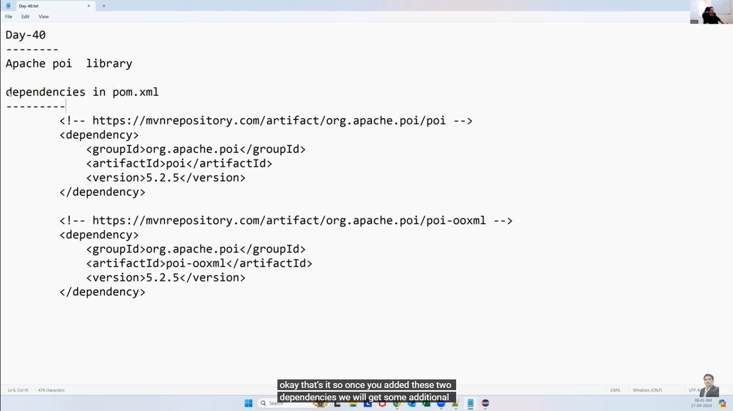

Data write in to excel:

Dynamic data write in to excel

Writing data in specific Row and cell

Excel Utils class;

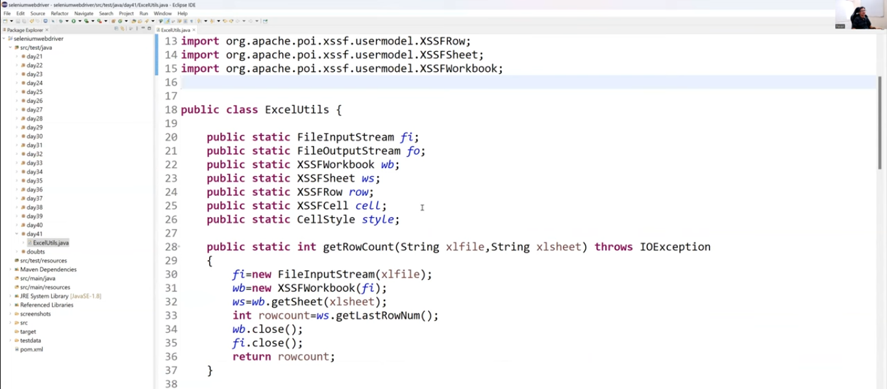

Data retrieve from excel.

TESTNG Integration:

